Daniel Callicoat
Visual Design and Communication

dcallicoat@gmail.com • (206) 495-5251 • 1771 Lawrence St, Eugene, OR 97401
Portfolio: www.DanielCallicoat.com Resume: www.DanielCallicoat.com/resume

This is a short excerpt from “Food Tour of Rome”, one of my many food and travel articles written for the website The Wandering Hedonist over the past three years. This introduction highlights the staples and typical dishes of Roman cuisine. The original article is followed by a series of detailed restaurant reviews and photographs of the food experienced during each meal.

You can read the full article on the website which provides a better context and the original web formatting. Gaps between text and photos here are an artifact of the paged document.

https://www.thewanderinghedonist.com/2022/04/10/food-tour-of-rome-italy/

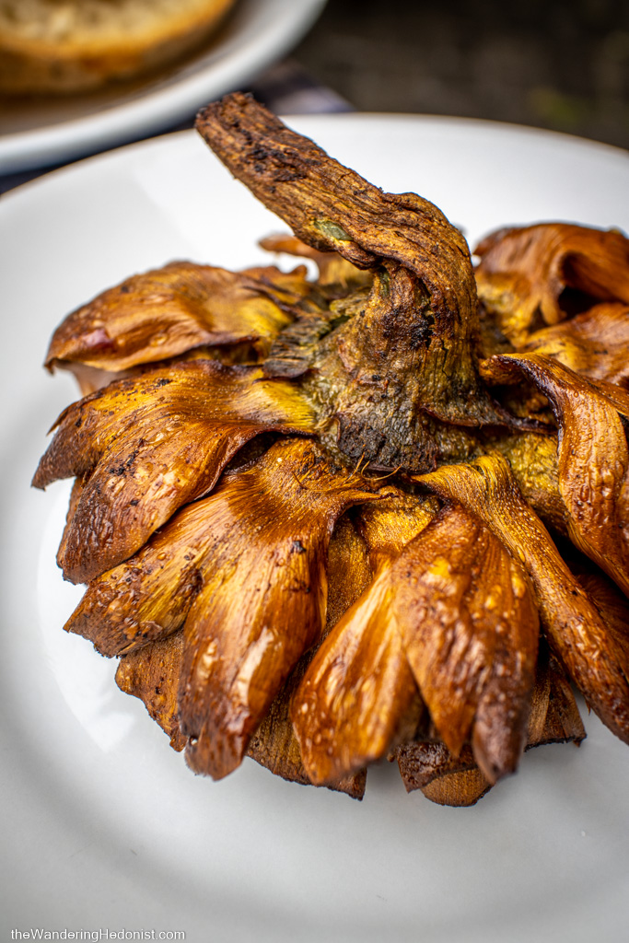
Carciofo alla giudìa

Each region of Italy has a unique style of food and most of it completely unlike the food you will find in an American Italian restaurant. Rome is no exception. Its traditional dishes are very much alive today and enjoyed across the city. Like all Italian cuisine, the focus is on what’s in season and what is grown locally.
Traditional local ingredients include: grains, fruits, nuts, olives and olive oil, beef, lamb, poultry, artichokes, fish (particularly anchovies), dairy and cheese (particularly pecorino Romano, a salty aged sheep’s cheese), and honey.
Rome also historically had a large Jewish population, so many of the celebrated peasant dishes are from Jewish origin.

The four Roman pastas
Though we tend to associate pasta with Italy, the first concrete information about its use wasn’t recorded until the 13th and 14th centuries. After that, dried pasta became popular for sea voyages and was exported all over the world. Tomatoes were not introduced to Italy until the 16th century and only became popular in Italian cuisine in the 17th century. The first recorded recipe for a tomato pasta sauce was by Roman chef Francesco Leonardi in his 1790 cookbook L’Apicio Moderno. Before that, pasta was eaten with the hands without sauce (the introduction of tomato sauces created the need for a fork). That said, pastas are popular in Rome and remain a staple of the cuisine often eaten every day.
Most regions in Italy have one or two internationally known traditional pasta dishes. Rome has four. Featuring black pepper and pecorino romano cheese, these four pastas build one to the next. These dishes were traditional shepherd dishes where the cheese and cured guanciale would keep without refrigeration - with the addition of an egg or tomato when available.
The first and most simple is cacio e pepe which uses just black pepper and pecorino romano, pasta, and a bit of pasta water to create an emulsion.

The second, gricia, starts with guanciale (cured pork jowl) finely cubed and rendered in a pan, then the pasta, pecorino, and pepper are added to cook and a bit of pasta water for the emulsion.

The next two are variations on the gricia.
The third, amatriciana, starts with guanciale, but then fresh tomatoes are added and cooked together. Then the pepper, cheese, and pasta are added.

The fourth, carbonara, is the same: guanciale, pepper, and pasta - but then a fresh egg or egg yolk is mixed with the cheese and added to the dish at the end.

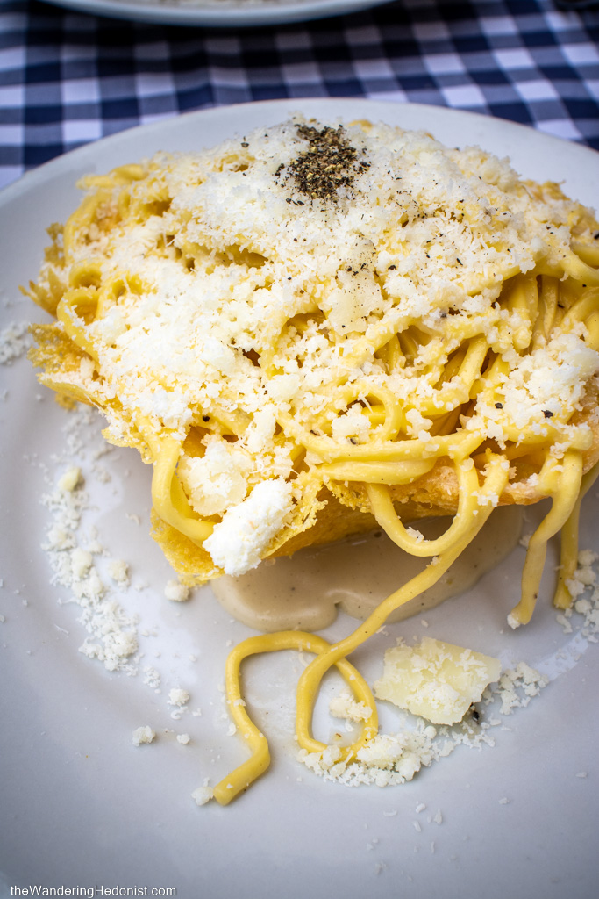
Cacio e pepe

Roman pizza
Pizza in Rome is very popular and comes in two distinct styles.
The first is pizza al taglio or by the slice. In this case, the “pizza” refers to a thick almost focaccia-like flatbread in long lengths available with a variety of toppings. The length is cut to order and sold by weight and then either warmed or served cold. This can be a quick lunch or a late-night bar snack.

The second is pizza tonda, a more traditional style round single-serving pizza made fresh and usually served at a table in a restaurant. Supposedly, the Roman style pizza is thinner and crispier, but honestly, I couldn’t tell much of a difference between Rome and Naples pizza. The crust is thin but with a good bulge at the edge, a bit chewy with lots of flavor, and cooked quickly in hot brick ovens.
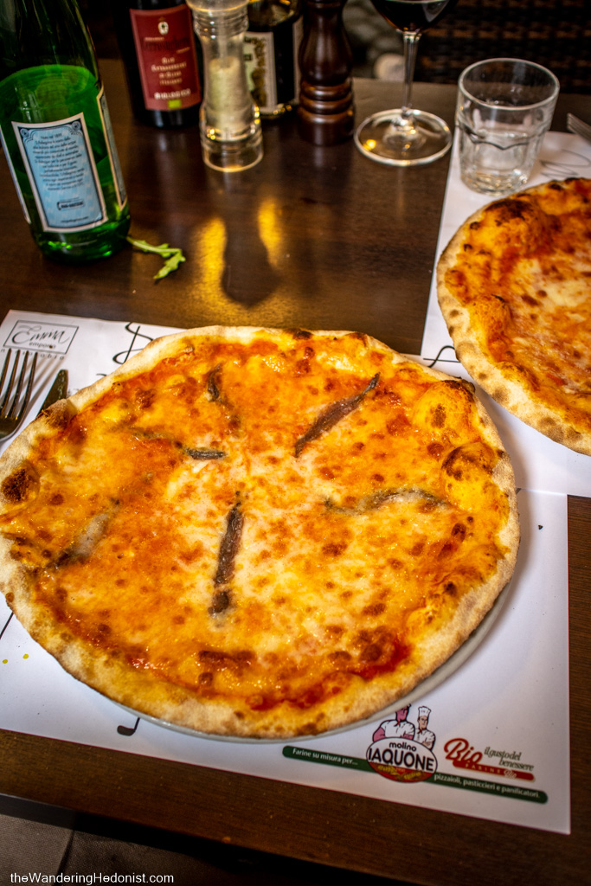
Pizza tonda

Vegetables
Vegetables are usually ordered on their own with main courses and typically include artichokes, bitter greens, and salads.
The most traditional dish is artichokes served in two different styles. Carciofo romanesco is trimmed and stuffed with a mix of finely chopped garlic, parsley, mint, oregano, and pepper, then braised until tender. Carciofo alla giudìa or Jewish style is smashed slightly to open the leaves, then deep-fried whole.

Also popular is the ubiquitous cicoria, a bitter green related to the dandelion, prepared ripassata (sautéed with olive oil, garlic, and a touch of chili) or all’agro (boiled and topped with lemon and a little olive oil).

Puntarelle con acciughe are the sprouts of Catalonian chicory served fresh as a salad with anchovies.

Fiori di zucca are also popular, zucchini flowers stuffed with mozzarella and anchovies, dipped in a batter, then deep fried.
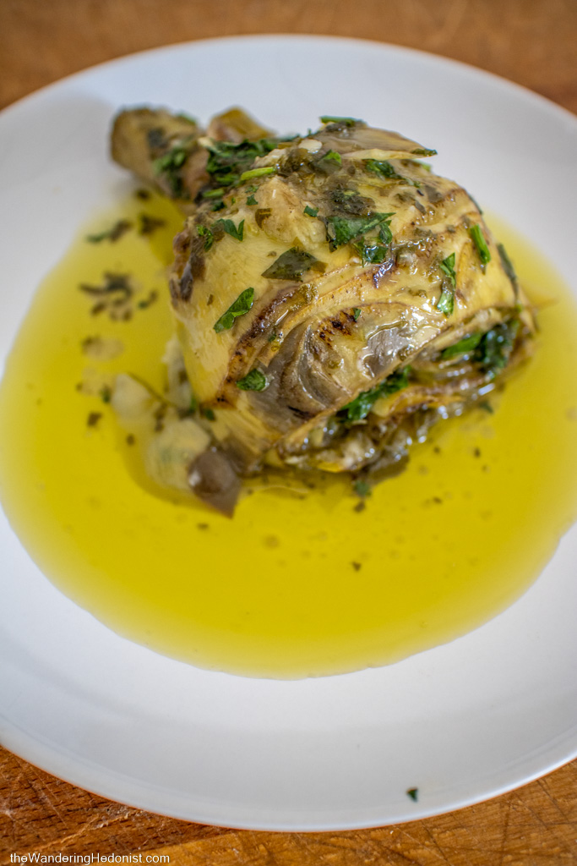
Carciofo romanesco

Meats
Meat in Rome is prepared in a similar style to Florence, either roasted, slow cooked, or braised. Preparations of offal, referred to as quinto quarto or fifth quarter, are very common and popular in traditional Roman cooking.
You will find slow cooked dishes like pollo con peperoni (chicken stewed with peppers), allesso di bollito (slow simmered beef), or coda alla vaccinara (the local version of oxtail with tomato sauce, herbs, pine nuts, raisins, and bitter cocoa). Or perhaps you’ll like the delicious slow roasted porchetta, often sliced and served as a sandwich.

Seared dishes like abbacchio allo scottadito (seared lamb, literally “scorched fingers”) or saltimbocca a la romana (pounded veal, prosciutto, and sage, stuffed and rolled up and cooked in white wine and butter) are also very popular.

Trippa alla romana or Roman tripe (stewed cow’s stomach) is some of the best tripe I’ve eaten, cooked slow in a tomato sauce until tender. There were two other offal dishes I had never tried before and I went out of my way to track them down.

Coratella coi carciofi, “Quinto quarto” cuts of meat, consists of heart, lungs, and other insides, slowly cooked with artichokes. This one was a bit difficult to track down but I did manage to find it.

Finally, we have pajata, the intestines of a suckling calf that still contain the partially digested mother’s milk. Lengths of the intestine are tied together in loops like a sausage and simmered in tomato sauce, then added usually to a rigatoni with some pecorino. The resulting “sauce” inside tastes a bit like ricotta cheese and the intestines are fairly soft, not chewy. Honestly, it tasted pretty good but I had trouble getting over the mother’s milk aspect for some reason.
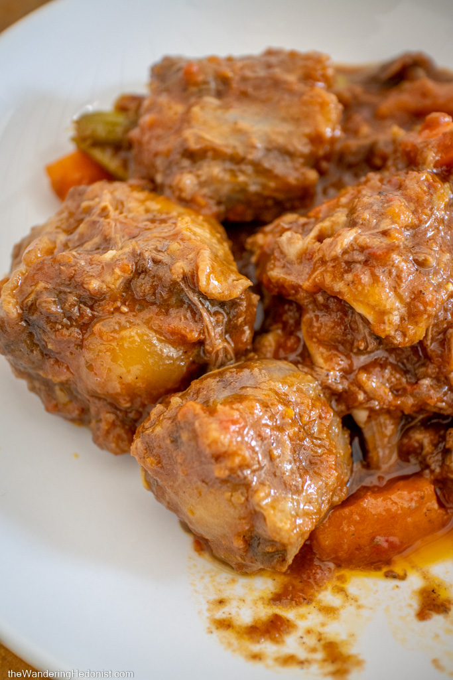
Coda alla vaccinara

Fried things and street food
Romans are also fond of fried bits usually eaten as street food. The most popular of these is the suppli or rice croquette. Rice is cooked with a sauce until thick and sticky, cooled and shaped into balls, then battered and deep fried - often with a bit of mozzarella inside. Although, we found supplis in a variety of flavors and styles.

Another recent invention is the trapizzino. A thick triangular piece of focaccia-like bread is opened on the wide side and filled with various ingredients like a meat ice cream cone. I tried four different kinds and loved them all.

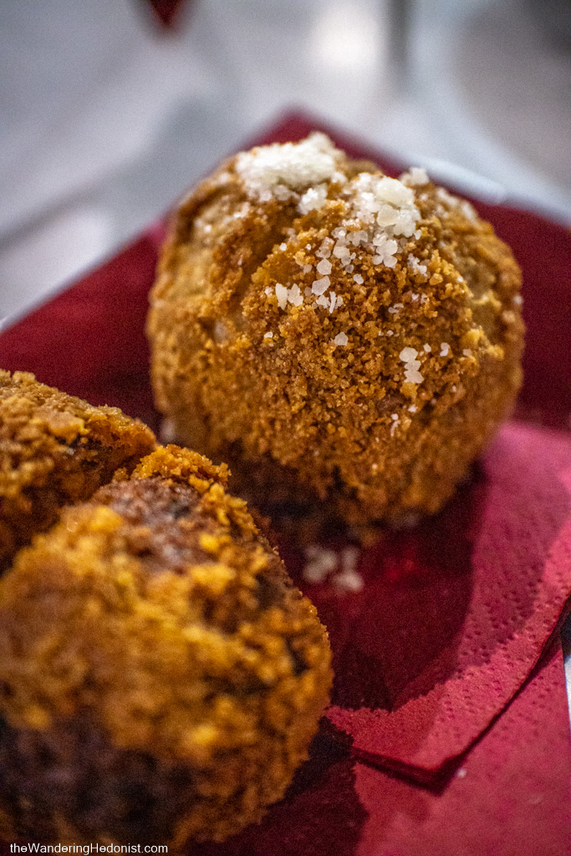
Classic suppli

Dessert
And last but not least, a few sweet things. The historic breakfast food in Rome was the maritozzi, an oblong yeast bun, split, then filled with a heavy unsweetened whipped cream. These can still be found in cafes across the city. Or try the more modern crostata ricotta e visciole, a sweet tart filled with ricotta and sour cherries. I prefer the sweetness of these tarts.

Of course, you’ll have no problem finding the well-known tiramisu or gelato which is everywhere you find tourists.
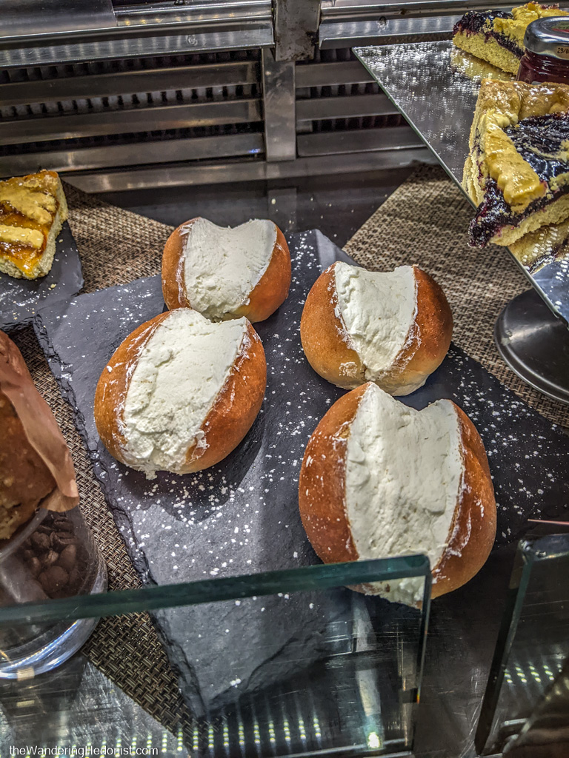
Maritozzi

